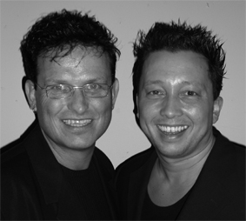
Hotel Belle

Choreografers : Roy Verdonk and Wil Bos
Level : Intermediate
Dance : 4 wall

Counts : 32 counts
Music : Hotel California – Belle Perez
CD : Baila Perez
Intro : 8 counts from first hard beat ( after guitar intro )

¼ Turn Step, Sailor ¼ Turn, Cross, ¼ Turn, Step, Close, Kick Ball Step
1 ¼ Turn left step right to right side,
2&3 Cross left behind right, ¼ Turn left step right next to left, Step left forward
4&5 Cross right over left, ¼ Turn right step left back, Step right back
6 Close left next to right
7&8 Kick right forward, Step right next to left, Step left forward

Skate, Skate ¼ Turn With Flick, Right Shuffle, Sync. Jazz Box ¼ Turn, Right Shuffle
1-2 Skate right, Skate left ¼ Turn left and flick right back
3&4 Step right forward, Step left next to right, Step right forward
5&6 Cross left over right, ¼ Turn left step back on right, Step left to left side
7&8 Step right forward, Step left next to right, Step right forward

Step, ¼ Turn, Cross Shuffle, Rockstep, ½ Turn Step, Step
1-2 Step left forward, ¼ Turn right
3&4 Cross left over right, Step right to right side, Cross left over right
5-6 Rock right forward, Recover,
7&8 Step right back , ½ Turn left step left forward, Step right forward

Rocking Chair, Scuff, ¼ Turn Hitch, Cross, Mambo, Side Shuffle
1&2& Step left forward, Recover, Step left back, Recover
3&4 Scuff left next to right, ¼ Turn right hitch left, Cross left over right
5&6 Rock right to right side, Recover, Step right next to left
7&8 Step left to left side, Close right next to left, Step left to left side

Start again and let the music touch your soul

